Craft Sales Continue to Grow by 50% Annually
By Michael Kinstlick

ADI 2014 Year-End Survey Results

The American Distilling Institute conducted its 2014 Year-End Survey in November. The results reveal the ongoing exponential growth in the American craft distilling market.

Two-hundred-sixteen distilleries from 39 states and several other countries responded. Excluding international entries (we focused on the US), the survey received 205 responses from US craft distilleries, 161 of which are currently in-production.

Highlights of the survey:

- Estimated craft distillery case sales volume grew by more than 50% over the previous year.

- Estimated craft distillery sales of 1.9 million cases, approaching 1% of total US distilled spirits volume.
  - 2013 sales volume of approximately 1.2 million cases.
  - 2012 sales volume of approximately 800,000 cases.

- Approximately 500 craft producers in the market at year-end 2014.

Production and Sales Volumes

The survey asked direct and indirect questions, regarding sales and production volumes. First, distillers were asked how many 9-liter cases (12 x 750 ml bottles) they sold in 2013 and 2014. Second, the survey asked how many cases DSPs expected to produce in 2014. Multiple-choice responses were based on the following ranges:

- Fewer than 500 cases
- 500–1,000 cases
- 1,000–2,500 cases
- 2,500–5,000 cases
- 5,000–10,000 cases
- 10,000 cases and up

This year, the survey added questions on the current number of employees and how many were added in 2014. Distillers were also asked how many distributors they work with and states they distribute in. The answers revealed strong relationships, as expected, between how many years a distillery has been in operation and their production and sales volumes, employment levels and distribution capabilities.

Using the results of these questions, the survey estimates sales and production in each range and analyzed the aggregated results by state, and distillery age (time in production).

Volumes by State

Several states are leaders, but the growth in numbers and case volumes produced is a truly across-the-country phenomenon. In 2013 and 2014, approximately eight states had production in excess of 50,000 cases, up from five in 2012.

Map 1: 2014 Case Volumes by State

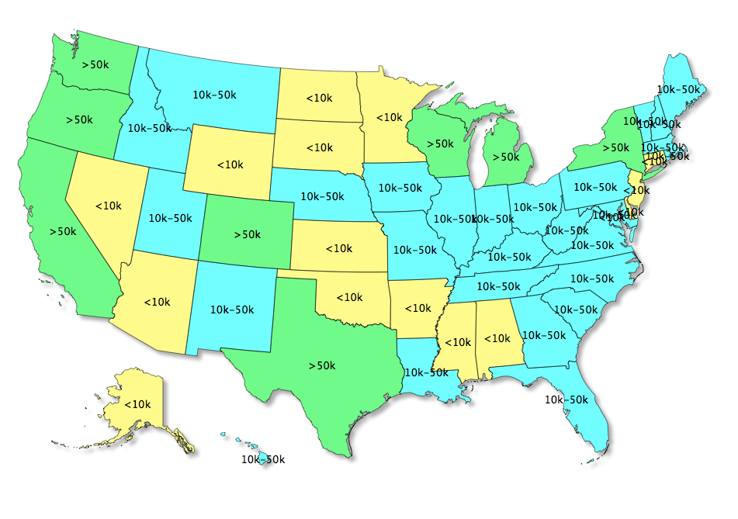

Volumes by Age (number of years in production)

The responses give information about the mix of volumes geographically and by distillery age. The craft distilled-spirits market is changing rapidly, and any survey is subject to changes in the mix of respondents relative to the full population.

Response rates were fairly consistent across the age distribution of the sample group. For aggregation and estimation purposes, respondents are grouped by time in production.

Table 1: Count of Respondents by Age

 | Known
Age | Producers | Respondents | % Response
6+ | 109 | 45 | 41%
4-5 | 86 | 21 | 24%
2-3 | 156 | 64 | 41%
0-1 | 74 | 32 | 43%
TOTAL | 425 | 162 | 38%

The expected pattern of production increasing relative to time in the market continues (as in past years) with distilleries more than 4 years old. However, there was a notable drop-off in reported production volumes in the younger producers. This could be the result of actual changes in the make-up of younger entrants, as compared with previous ones, or it could be the result of fewer of the larger recent entrants responding.

Table 2: Average Sales & Production Volumes by Age

 | 2014 Survey | 2014 Survey | 2013 Survey | 2012 Survey
Years in Production | 2014 Sales | 2013 Sales | 2012 Sales | 2011 Sales
6 or more | 5858 | 4989 | 3850 | 5000
4-5 | 4300 | 2952 | 2550 | 3700
2-3 | 1321 | 676 | 2350 | 1750
0-1 | 1031 | 484 | 400 | 575

 | 2014 Survey | 2013 Survey | 2012 Survey
Years in Production | 2014 Production | 2013 Production | 2012 Production
6 or more | 6733 | 5100 | 6300
4-5 | 4679 | 3550 | 4800
2-3 | 1798 | 4850 | 3000
0-1 | 945 | 1425 | 1450

Employment by State

The survey asked how many employees (full-time-equivalent) respondents had in range of:
- 0,
- 1-5,
- 6-10,
- 11-24, and
- 25 or more.

The aggregate results suggest total employment in the craft distilling industry is approaching 2,000 jobs nationally.

Map 2: Craft Distillery Employment by State

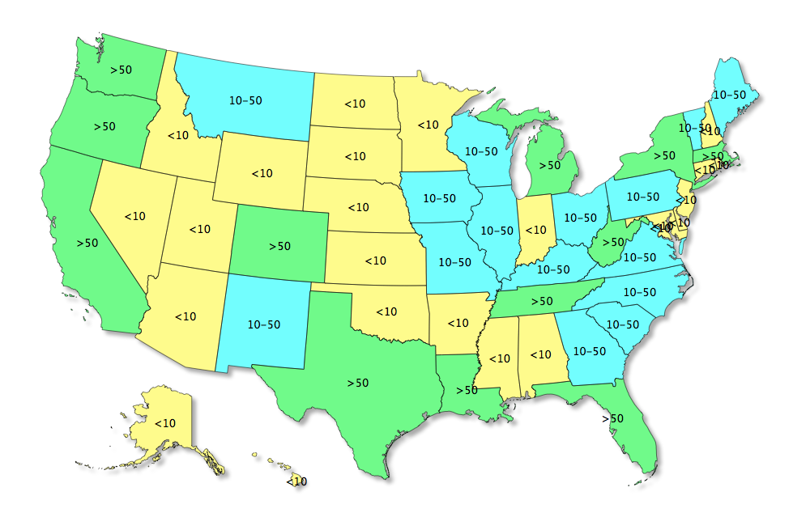

Not surprisingly, employment closely follows production volumes. And we see not only growth in direct jobs across the country, but also follow-on effects as craft distilleries are involved in local communities to a much greater extent than major spirits brands.

Conclusion

The craft distilled spirits market in the US continues to grow along its established trajectory. The 2014 survey validates the market’s growth both in number of entrants, and expansion by existing entrants. Should the trend continue, by 2020 there will be well over 1,000 craft distilleries, approaching 7-8% of total US distilled spirits volumes sold.

We analyzed only craft distilleries that have agreed to an upper production limit of 100,000 proof gallons, or about 40,000 nine-liter cases. A small number of entrants originally under the “craft distillery” label have since exceeded those volumes.

